27 January 2026
18:28

Case | Query (adapted) | Multi-hop path | Expected Results | Actual results | Remarks
1 | Find patients PRESCRIBED Lisinopril (or equivalent) who were DIAGNOSED_WITH Rhabdomyolysis within 30 days of the prescription, and whose nodes or related clinical data mention 'myalgia' or 'muscle pain'. | - Path: Medication (Lisinopril) — [GDS Similarity] → Medication (Related) ← [IS_PRESCRIBED] — Patient — [IS_DIAGNOSED_WITH] → Condition (RDM)  - Attributes Checked: [similarity score], [start_date], [occurrence_date], [clinical_summary: "myalgia" OR "muscle pain"] | 2 patients: Priya and Rajendran (clinical notes states "soreness")  Medications: Lisinopril and Atorvastatin (linked by similarity). | 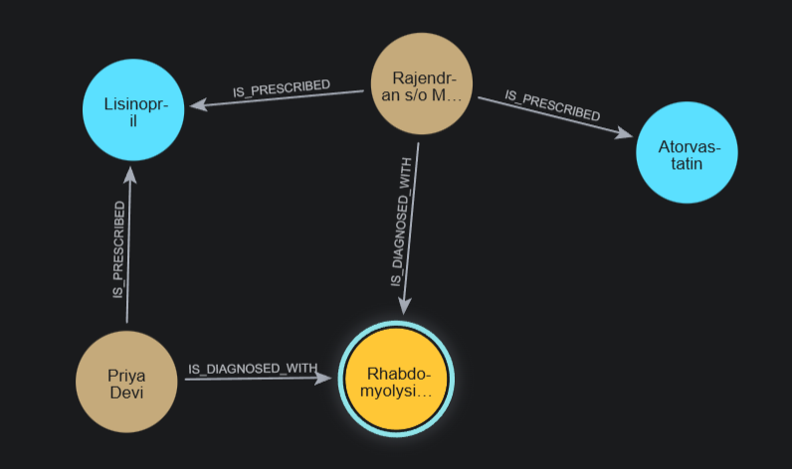  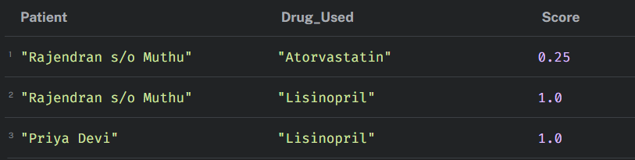 | "equivalent" works using GDS similarity between drugs  Priya direct signal  Rajendran equivalent signal
2 | Find patients who were on a medication, experienced a Trigger (Statin-Induced Myopathy), and were switched to a different medication within 48 hours. | - Path: Patient — [IS_PRESCRIBED] → Medication (Old) AND Patient — [IS_PRESCRIBED] → Medication (New)  - Attributes Checked: [start_date (Old)], [start_date (New)], [occurrence_date (Trigger)], [time_diff: <= 48 hours] | Patient: Tan Wei Ling  Was on Atorvastatin, experienced "Statin-Induced Myopathy", switched to Ezetimibe" within 48hr | 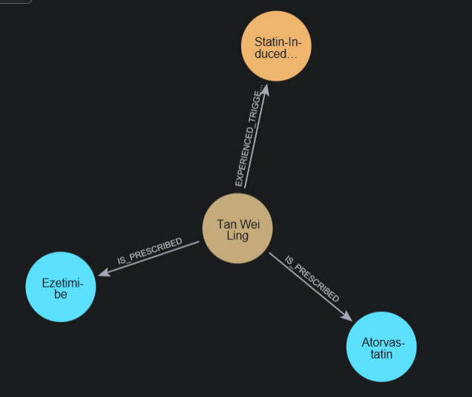  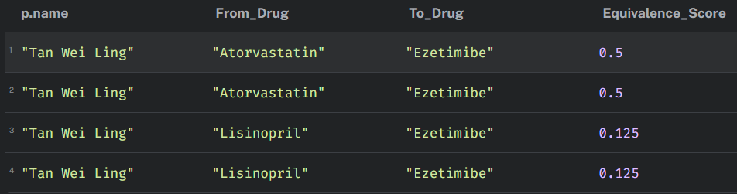 | drug switch to a clinically equivalent one which is functionally or structurally similar
3 | Find cases where the PRESCRIBED duration for Atorvastatin and Lisinopril overlapped in time, followed by an occurrence_date for a Condition_RDM diagnosis. | - Path: Patient — [IS_PRESCRIBED] → Medication (Atorvastatin) AND Patient — [IS_PRESCRIBED] → Medication (Lisinopril) — [Sequence] → Condition (RDM)  - Attributes Checked: [start_date (Med 1)], [duration_days (Med 1)], [start_date (Med 2)], [duration_days (Med 2)], [occurrence_date (Diagnosis)] | Patient: Rajendran  Drugs: Lisinopril and Atorvastatin, injury occurred exactly 14 days after the second drug was added | 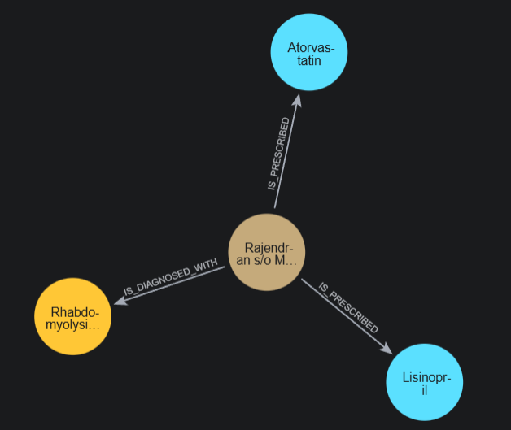  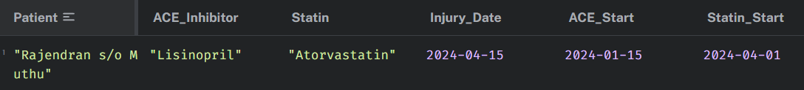 | Shows drug overlap window, currently just native query filter and match
4 | Across the entire population, what is the incidence rate of RDM within 30 days of a patient being on a high-risk co-exposure (any ACE Inhibitor + any Statin), and does a history of Hypertension significantly accelerate the time-to-injury?  Modified from "Sample Query" slide | - Path: Condition (Hypertension) ← [HAS_HISTORY] — Patient — [IS_PRESCRIBED] → (Med 1 + Med 2) — [IS_DIAGNOSED_WITH] → Condition (RDM)  - Attributes Checked: [occurrence_date (Hypertension)], [start_date (Meds)], [occurrence_date (RDM)], [time_to_injury gap] | summary of the drug-drug interaction (DDI) risk  Patient count + drug combo | 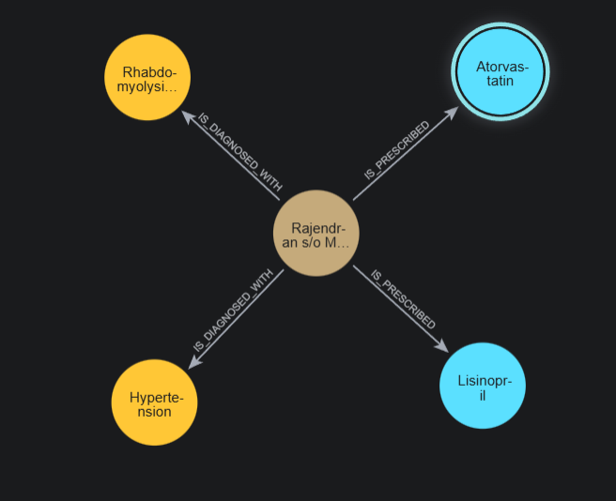  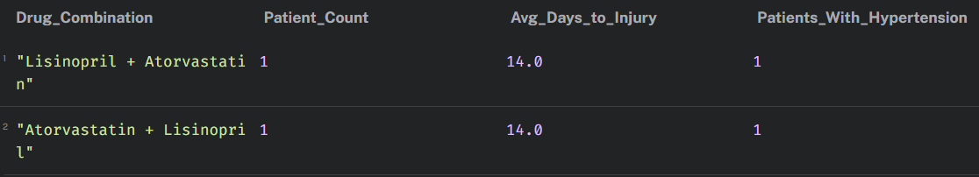 | GDS finds patients on drugs equivalent to the high risk pair  Currently only Rajendran matches
5 | Identifies patients who haven't been diagnosed with RDM yet, but whose clinical profile (conditions and history) is highly similar to patients who have been diagnosed  Condition match | - Path: Patient (Diagnosed Case) — [IS_DIAGNOSED_WITH] → Condition ← [IS_DIAGNOSED_WITH] — Patient (Not Yet Diagnosed)  - Attributes Checked: [Jaccard similarity score], [clinical_summary (for profile matching)], [age], [gender] | Condition combo + patient match %  + shared conditions | 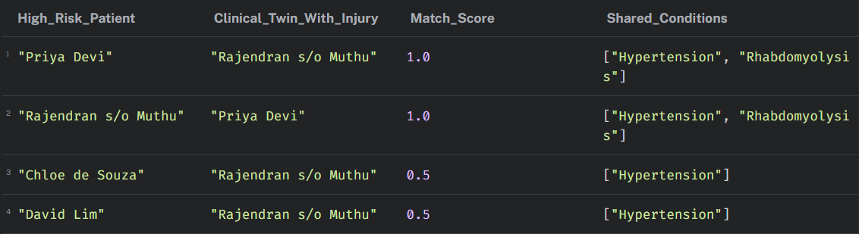 | Using Rajendran as base to compare
6 | Identify patients who share a clinical profile with known injury cases and are currently exposed to high-risk polypharmacy, but have not yet manifested RDM  Patients at risk of RDM | - Path: Patient (Candidate) — [GDS Similarity] → Patient (Case) AND Patient (Candidate) — [IS_PRESCRIBED] → Multiple Medications  - Attributes Checked: [similarity score], [start_date (active prescriptions)], [duration_days], [clinical_summary (absence of RDM keywords)] | Patient + Risk summary % + flag  Tan Wei Ling flagged as critical | 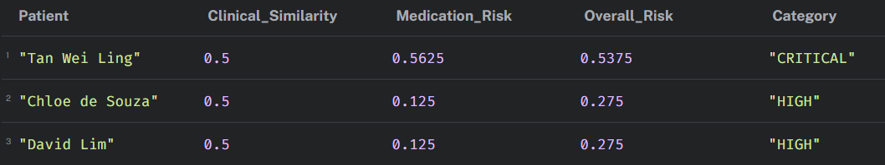 | Combines and weights Case 4&5

